SQL queries and POWEBI DAX measures for loan data Analysis
SQL Queries
1. Total & Average Loan Amount
sql
SELECT
SUM(loan_amnt) AS total_loan_amount,
AVG(loan_amnt) AS avg_loan_amount
FROM loan_data;

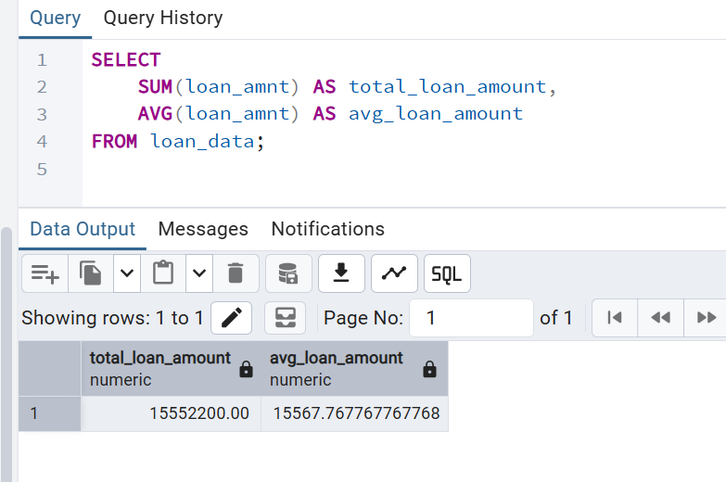
2. Loan Status Breakdown (%)
sql
SELECT
loan_status,
COUNT(*) AS loan_count,
ROUND(COUNT(*) * 100.0 / (SELECT COUNT(*) FROM loan_data), 2) AS pct_of_total
FROM loan_data
GROUP BY loan_status
ORDER BY loan_count DESC;
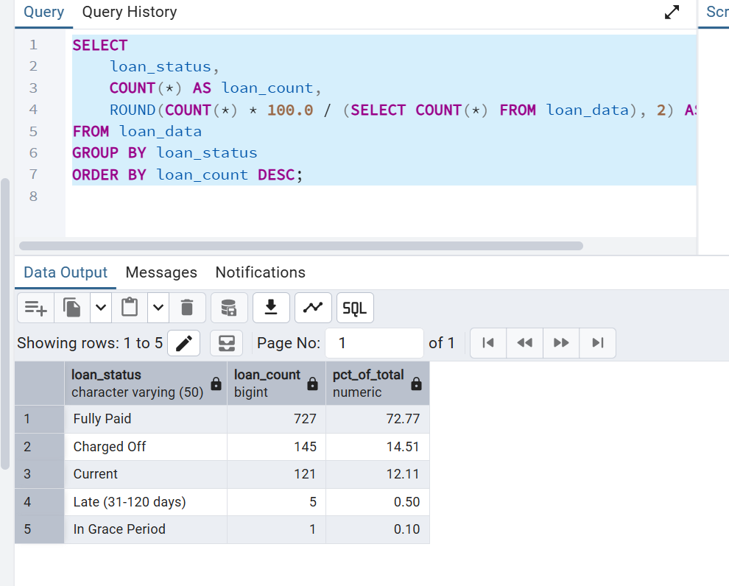
3. Average Interest Rate by Grade
sql
SELECT
grade,
ROUND(AVG(CAST(int_rate AS DECIMAL(5,2))), 2) AS avg_interest_rate
FROM loan_data
GROUP BY grade
ORDER BY grade;
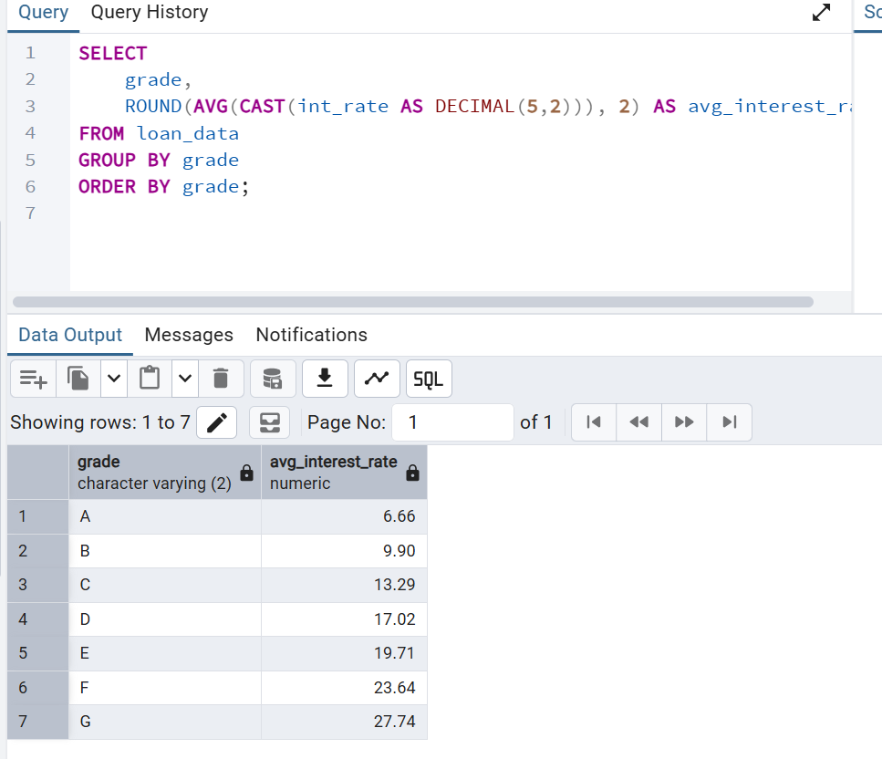
4. Loan Count & Amount by Term
sql
SELECT
TRIM(term) AS term,
COUNT(*) AS loan_count,
SUM(loan_amnt) AS total_loan_amount
FROM loan_data
GROUP BY TRIM(term);
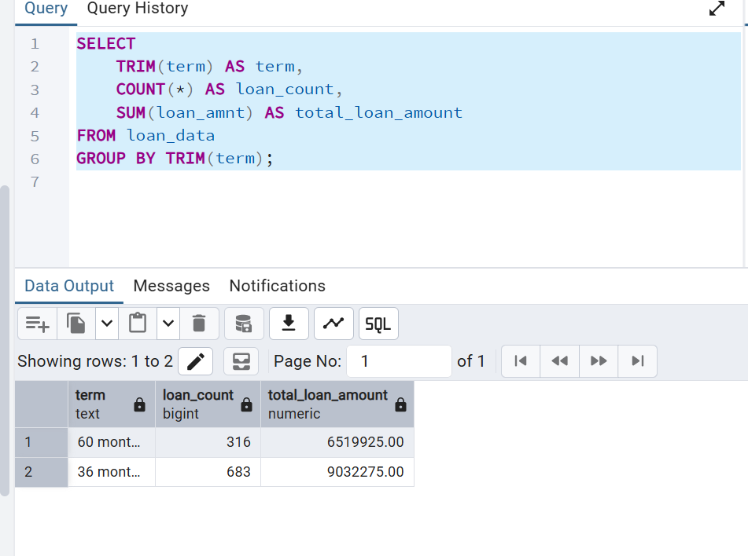
5. Average Annual Income by Home Ownership
sql
SELECT
home_ownership,
ROUND(AVG(annual_inc), 2) AS avg_annual_income
FROM loan_data
GROUP BY home_ownership
ORDER BY avg_annual_income DESC;

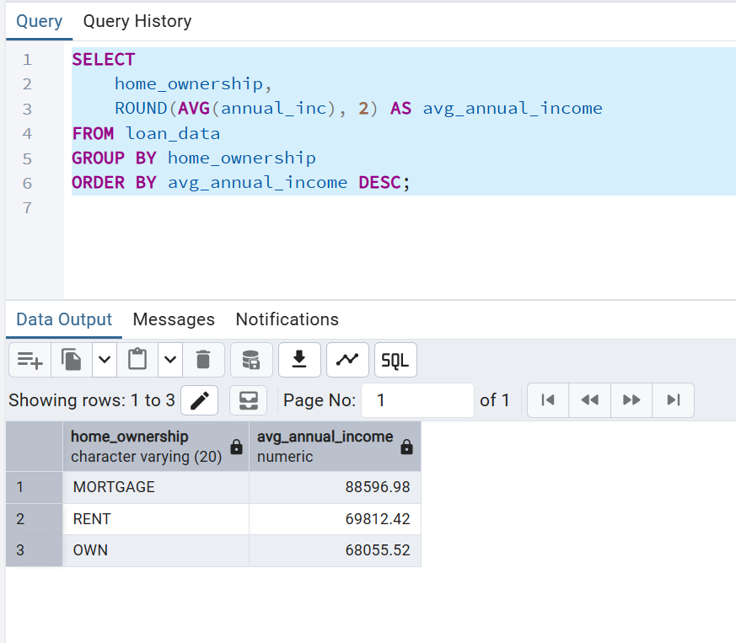
6. Top Loan Purposes by Volume
sql
SELECT
purpose,
COUNT(*) AS loan_count,
SUM(loan_amnt) AS total_loan_amount
FROM loan_data
GROUP BY purpose
ORDER BY total_loan_amount DESC;

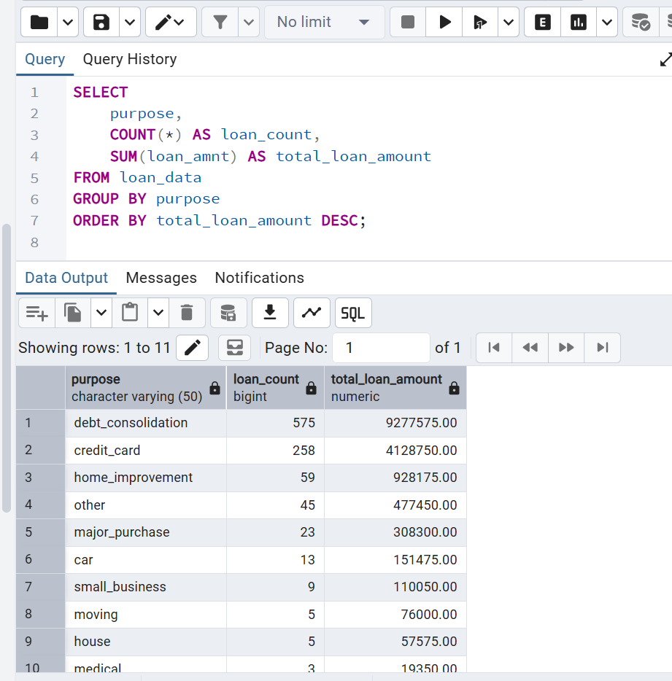
7. Average DTI by Grade
sql
SELECT
grade,
ROUND(AVG(dti), 2) AS avg_dti
FROM loan_data
GROUP BY grade
ORDER BY grade;
8. Employment Length Distribution
sql
SELECT
CASE
WHEN emp_length = '< 1 year' THEN 'Less than 1 year'
WHEN emp_length IN ('1 year','2 years','3 years','4 years','5 years') THEN '1-5 years'
WHEN emp_length IN ('6 years','7 years','8 years','9 years') THEN '5-10 years'
WHEN emp_length = '10+ years' THEN '10+ years'
ELSE 'Not Specified'
END AS emp_length_bucket,
COUNT(*) AS loan_count
FROM loan_data
GROUP BY
CASE
WHEN emp_length = '< 1 year' THEN 'Less than 1 year'
WHEN emp_length IN ('1 year','2 years','3 years','4 years','5 years') THEN '1-5 years'
WHEN emp_length IN ('6 years','7 years','8 years','9 years') THEN '5-10 years'
WHEN emp_length = '10+ years' THEN '10+ years'
ELSE 'Not Specified'
END;

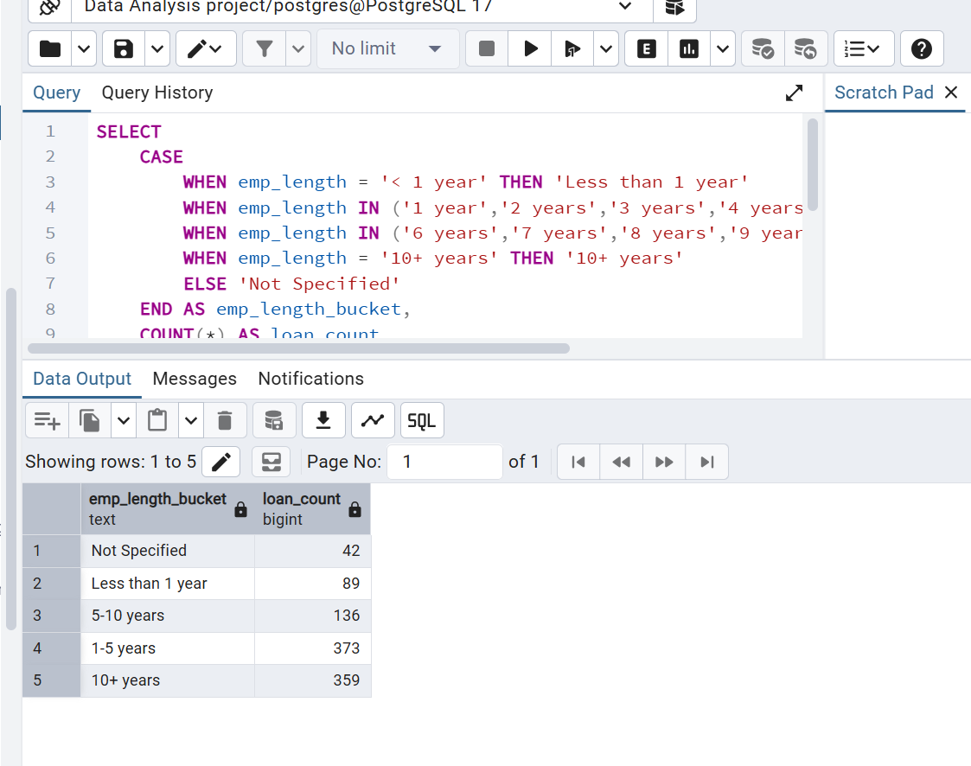
9. Delinquency Rate (delinq_2yrs > 0)
sql
SELECT
ROUND(SUM(CASE WHEN delinq_2yrs > 0 THEN 1 ELSE 0 END) * 100.0 / COUNT(*), 2) AS delinquency_rate_pct
FROM loan_data;
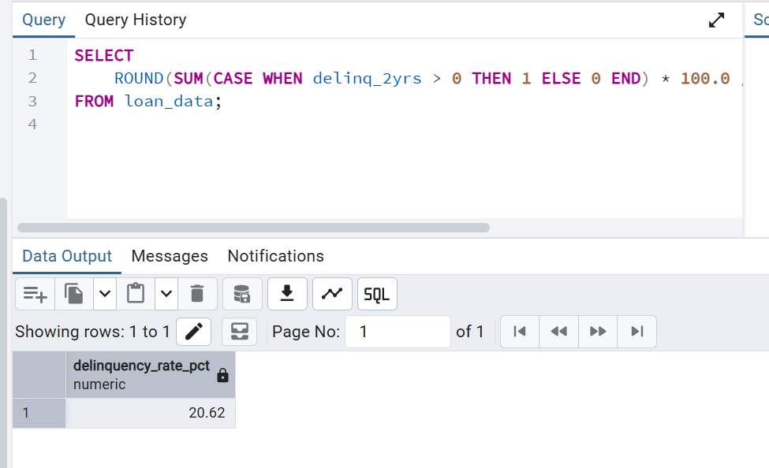
10. Verification Status Split
sql
SELECT
verification_status,
COUNT(*) AS loan_count,
ROUND(COUNT(*) * 100.0 / (SELECT COUNT(*) FROM loan_data), 2) AS pct_of_total
FROM loan_data
GROUP BY verification_status;

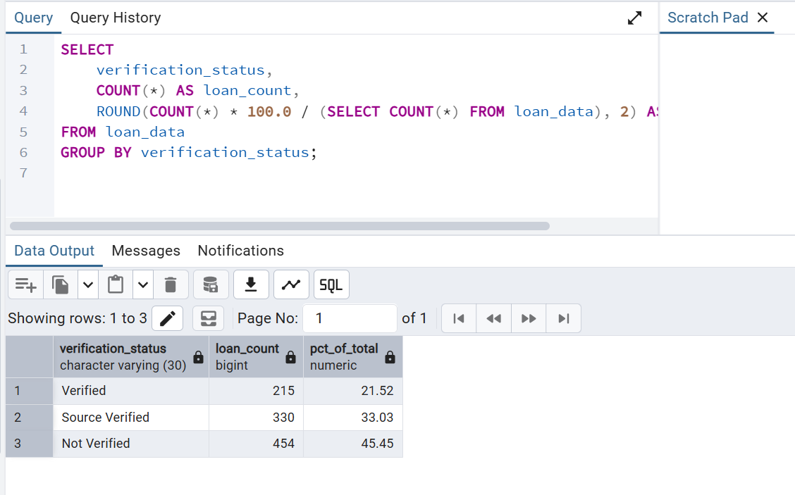

Power BI DAX Measures
DAX
-- 1. Total & Average Loan Amount
Total Loan Amount = SUM(loan_data[loan_amnt])
Avg Loan Amount = AVERAGE(loan_data[loan_amnt])

-- 2. Loan Status %
Loan Status % =
DIVIDE(
COUNTROWS(loan_data),
CALCULATE(COUNTROWS(loan_data), ALL(loan_data))
)

-- 3. Average Interest Rate by Grade
Int Rate (Numeric) = VALUE(loan_data[int_rate])
Avg Interest Rate = AVERAGE(loan_data[Int Rate (Numeric)])

-- 4. Loan Count & Amount by Term
Loan Count = COUNTROWS(loan_data)
Total Amount by Term = SUM(loan_data[loan_amnt])

-- 5. Average Annual Income by Home Ownership
Avg Annual Income = AVERAGE(loan_data[annual_inc])

-- 7. Average DTI by Grade
Avg DTI = AVERAGE(loan_data[dti])

-- 8. Delinquency Rate
Delinquency Rate =
DIVIDE(
CALCULATE(COUNTROWS(loan_data), loan_data[delinq_2yrs] > 0),
COUNTROWS(loan_data)
)
-- formated this measure as a percentage in the visual

